File permissions in Linux

Project description
As a security analyst at an international organization, who primarily works with a research team, I need to ensure that the research team members have permissions only necessary for their duties. The principle of the least privilege decreases the attack surface and, consequently, improves organization's security.
In order to ensure that permissions correspond to provided authorization, I have to examine permissions in the file directory. In case of any disparities, I will need to amend those by using authorization commands in a Linux bash.

Check file and directory details
One way to check for a list of files and subdirectories in some directory is through using a ls command. An -l operant is used for displaying operation, and an -a operant lists hidden or restricted files or directories.
The list of permissions returned is as follows:
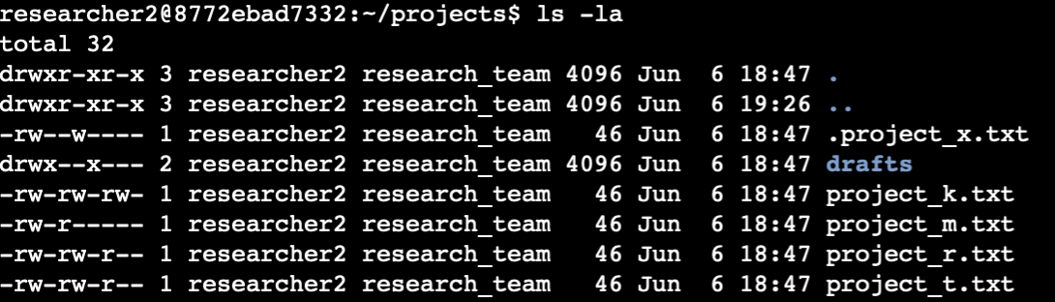

Describe the permissions string
As we can see, the first string returned is drwxr-xr-x. The character d signifies that it is a directory. If it is (-) at the beginning, it is a regular file. The next three characters describe permission for a user which is researcher2. The (r), (w), (x) symbols mean that researcher2 can read, write, and execute files in this directory respectively. The 4th, 5th, and 6th symbols describe permission for a group which is research_team. We can conclude that the group does not have permission to write to the directory, provided that there is a (-) symbol instead. The last three symbols stand for permissions for “others” — anyone who is not researcher2 or who is not included in research_team. Others do not have any permissions provided that there are three (-) in a row.

Change file permissions
The company’s policy is that third parties cannot edit files or manage subdirectories. As we can see from the output I posted above, the following document does not follow this policy:
To change it, I ran the following command:
The chmod command stands for “change permissions”. We can edit permissions for users, groups and others by specifying (u), (g), and (o) operands respectively. To grant or remove permissions, we can use (+) and (-) signs. For example, as in the command above, I removed writing permissions for others by writing o-w. Lastly, we specify the file name for which we want to modify permissions.
Change file permissions on a hidden file
The project file .project_x.txt is hidden as it is indicated by a (.) symbol. It is hidden since the research team has archived it recently. No one should have writing permissions on this file, although the user and group should have reading permission.
We can see that only the user has written permissions, and both the user and group have writing permission. To align permissions with current project requirements, I ran the following command:
Note that there is no space after coma when we change permissions for different categories of users. Also you can completely “reset” permissions and set them to a new value by using (=) sign. As with group users, and since we needed to remove writing and add reading permissions for the group, it is easier to accomplish by a single operation.

Change directory permissions
Last, but not least, project files and directories owned by the researcher2 user, and hence only researcher2 must be allowed to access drafts directory and the content within it.
Seeing as all possible permission are granted for the user and removed for others as below
I executed the following command:
I left the field blank after the (=) sign, which means there are no permissions. At the end of the string I specified the name for the directory, which is drafts.

Summary
First, I executed ls command to check for current files, directories, and permissions aligned to them. Then, I described the permissions string and what each symbol in the string stands for and relates to. After that, I changed file permissions and elaborated on the chmod command I used to achieve this. Finally, I removed all superfluous permissions for drafts directory, and at the end reviewed permissions with the ls -la command so as to ensure that I executed previous steps properly.
